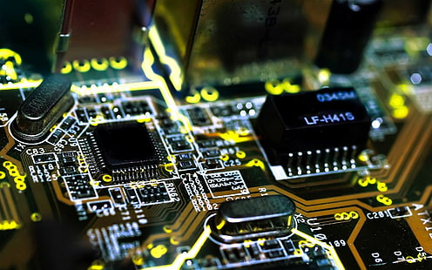

Contact us

Limited seats

Contact us 9989898767676

Program offered

Computer hardware

Computer science

Mobile repairing

banking



[This Photo](https://www.pngall.com/qr-code-png/) by Unknown Author is licensed under [CC BY-NC](https://creativecommons.org/licenses/by-nc/3.0/)



[This Photo](https://www.pngall.com/qr-code-png/) by Unknown Author is licensed under [CC BY-NC](https://creativecommons.org/licenses/by-nc/3.0/)



[This Photo](https://foto.wuestenigel.com/freshly-cut-vegetables-on-plate/) by Unknown Author is licensed under [CC BY](https://creativecommons.org/licenses/by/3.0/)



Literacy India Community college (LICC)